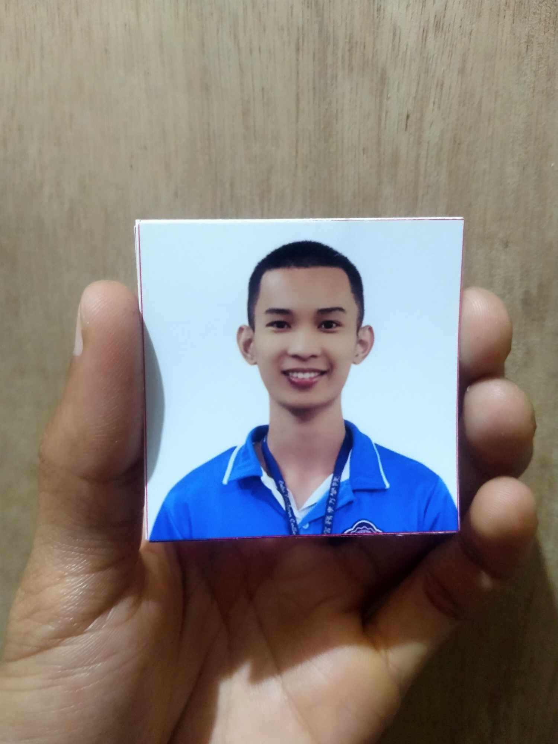 **JEAN HENRI MENDOZA**

**Panagdait, Kasambagan, Cebu City**

**09563043687**

**jeanhenrimendoza@gmail.com**

**OBJECTIVE**

* To acquire valuable knowledge and skills to complement those that I’ve learned from school in an actual job environment. In return, I offer my service and determination to be an asset to your company throughout the duration of my work immersion period.
* Goal-oriented and responsible College student, seeking to apply for a challenging opportunity where I will be able to utilize my planning skills, analyze skills, I will use my skills in the best possible wat to achieve the company’s goal, which allow me to grow personally and professionally.

**PERSONAL DATA**

Name : Jean Henri Mendoza

Date of Birth : September 16, 2002

Place of Birth : Mandaue City, Cebu

Age : 21

Sex : Male

Religion : Roman Catholic

Nationality : Filipino

Language spoken: Cebuano, Filipino, English

Status : Single

**EXPERIENCE**

**Online Immersion (2020 - 2021)**

**CISCO**

In this course, you'll learn the ins and outs of networking, starting with troubleshooting common issues in home and small business setups. We'll guide you through building a simple network using Cisco devices, giving you practical experience with real-world equipment. You'll also dive into the TCP/IP suite, understanding how these protocols keep networks running smoothly. Plus, you'll gain the skills to identify and fix common problems with hardware, software, and networks, ensuring you're prepared to handle any challenges that come your way.

**EDUCATIONAL BACKGROUND**

**College**

2021 - Present

Bachelor of Science in Information Technology

Cebu Eastern College

Leon Kilat St, Cebu City

**Senior High School**

2019 – 2021

Technical-Vocational Livelihood (Computer System Services)

University of Cebu-Pri Main Campus

Sanciangko St, Cebu City

**Junior High School**

2015 - 2019

Mabolo National High School

Juan Luna Avenue, Cebu City

**Elementary School**

2008 - 2015

Subangdaku Elementary School

597 Lopez Jaena St, Mandaue City, 6014 Cebu

**AWARDS AND CERTIFICATES**

CISCO Networking Essentials Certificate

CISCO Get Connected Certificate

CISCO Introduction to Packet Tracer Certificate

CISCO Introduction to Cybersecurity Certificate

CISCO Introduction to IoT Certificate

2020 – 2021

University of Cebu-Pri Main Campus

Sanciangko St, Cebu City

PSITE Cebu ICT Student Congress

March 15, 2024

Cebu Institute of Technology - University

**SKILLS**

* Detailed with strong analytical and problem solving skills
* Motivated, determined and consistent
* Adaptability
* HTML
* CSS
* Javascript

**CHARACTER REFERENCES**

**Mrs. Juvelyn G. Sato**

IT Dean

Cebu Eastern College

**Mrs. Juvelyn G. Sato**

ITPracticum Coordinator

Cebu Eastern College

*I hereby certify that the above information is true and correct to the best of my knowledge and belief.*

**Applicant’s Signature**